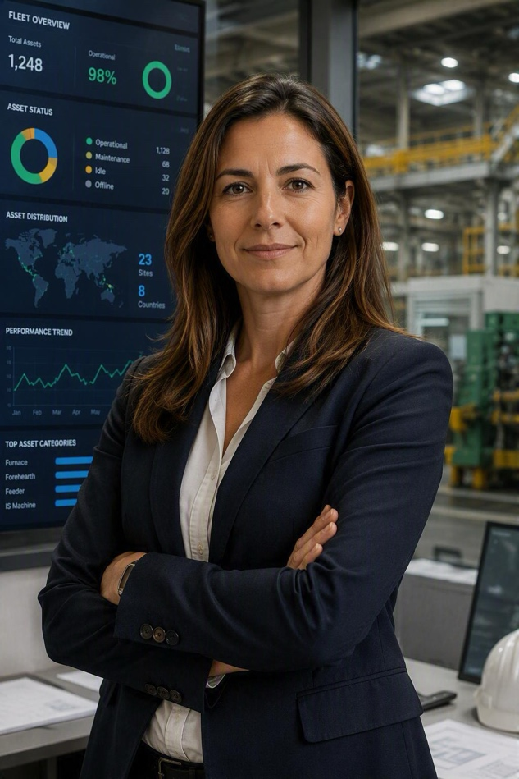
High (4/5)

Digital Maturity
Comfortable using dashboards, analytics, and enterprise systems to monitor fleet performance, compare sites, and support strategic asset decisions.

Bio
Julia is responsible for managing equipment strategy across multiple plants. She focuses on standardisation, fleet performance, and long-term asset planning to improve efficiency and reduce operational complexity.



Goals
Key tasks
Julia
Fleet & Engineering Manager
- Standardise equipment across sites
- Improve fleet performance
- Reduce maintenance costs
- Increase asset reliability
- Support strategic investment decisions

- Review fleet performance
- Standardise equipment
- Plan asset investments
- Compare site performance
- Optimise asset utilisation
- Define maintenance strategy

“I need a clear overview of
our global equipment fleet so I can make informed decisions that improve performance and reduce complexity.”

JTBD
Standardise and optimise equipment across multiple sites.

Department
Corporate Engineering & Asset Management

Work environment
Corporate office, multiple production sites, fleet management dashboards



Needs
- Fleet-wide asset visibility
- Equipment performance insights
- Cross-site benchmarking
- Standardisation opportunities
- Investment planning data
- Reliable asset lifecycle information
- Confidence that fleet decisions are based on consistent data across sites.

Pain points
- Limited cross-site visibility
- Inconsistent equipment standards
- Fragmented asset information
- Difficult fleet-level planning
- Complex spare-part management

